**Instructions for HIPAA and Biomedical Research Training**

1. Go to https://www.citiprogram.org/

2. Click “Register” on the right-hand side of the page

3. Under “Select your Organization Affiliation”, type “University of California, Los Angeles (UCLA)” and then click the boxes to “Continue to Create Your CITI Program Username/Password”

4. Enter personal information

5. Select “No” for CE functionality and select your own answer for whether the CITI Program can contact you later

6. Enter your institutional information and select your corresponding role under the “Role in research”

7. Then you will probably see a set of questions, please select according to the screenshot below if you have never completed any CITI training (questions not shown are option, please choose with your best judgement):

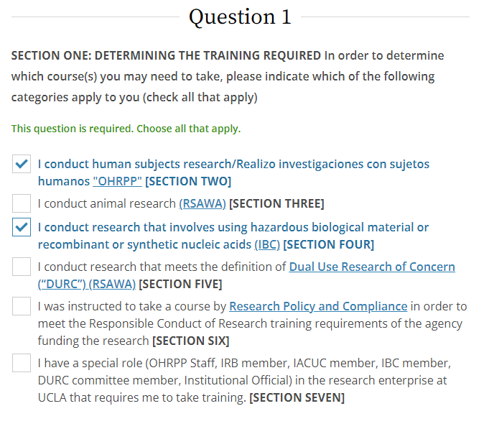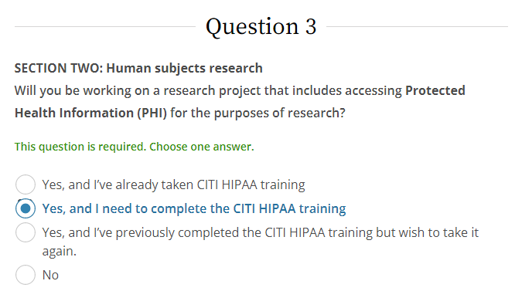

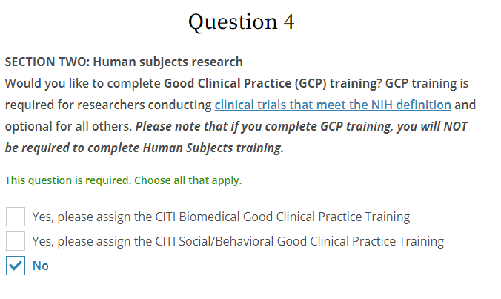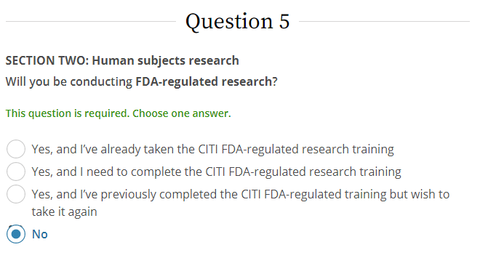

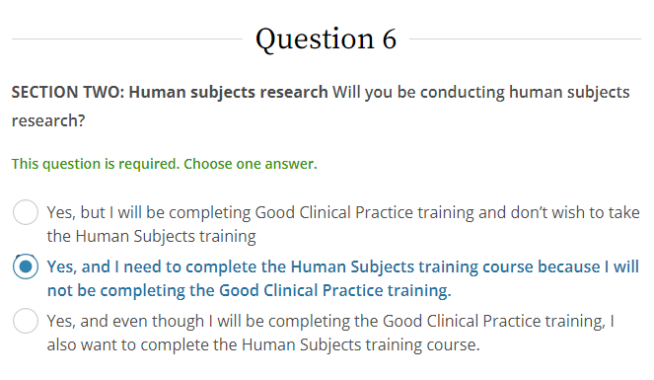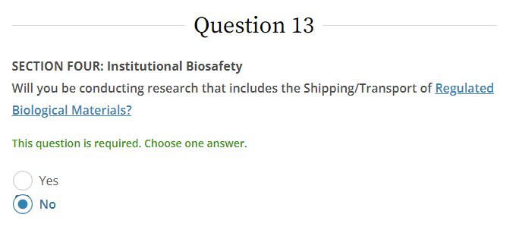

8. Click “Complete Registration”

9. Click “Finalize Registration”

10. Click the menu option for “University of California, Los Angeles” and click on **Group 1 Human Subject Research** and **UCLA HIPAA** links to complete required training.

11. After completing each quiz, if you do not score 100%, study the correct answers and click the option to return to the module and retake the quiz

12. After completion of the course, click “Print Report” and save the report with your last name at the beginning of the filename

13. Email the two certificates to me.